

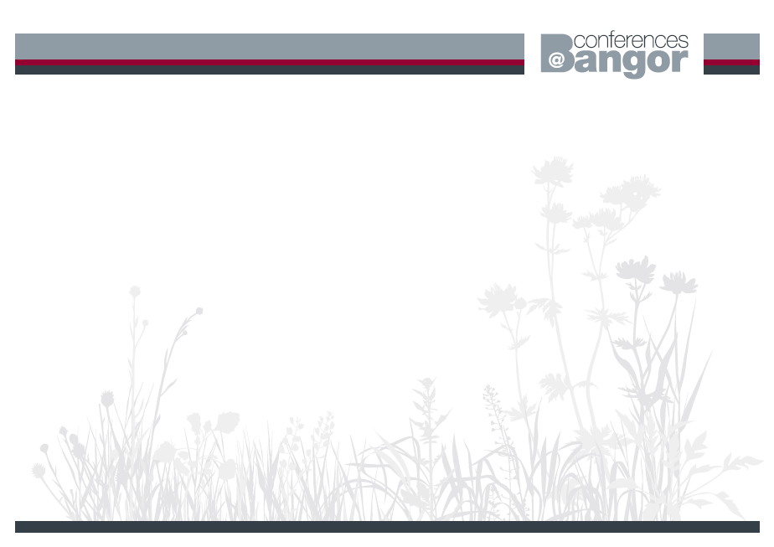

**CONFERENCE SERVICES ACCOMMODATION FORM**

**COGNITIVE LINGUISTICS UK-CLC CONFERENCE – BANGOR UNIVERSITY**

**19th July – 21st July 2016**

Please complete and return the booking form to: Sharon Hughes, Conference Services, Neuadd Reichel, Bangor University, Ffriddoedd Road, Bangor, Gwynedd LL57 2TR

Tel: (01248) 38 2822 Email: [s.hughes@bangor.ac.uk](mailto:s.hughes@bangor.ac.uk)

**ACCOMMODATION BOOKINGS MUST BE PAID FOR IN ADVANCE. PLEASE PRINT CLEARLY**

|  |  |  |
| --- | --- | --- |
| Title: | First Name: | Surname: |
| Address (for your confirmation): | | |
| Daytime Telephone: | | |
| Email address (*Please print clearly*): | | |

|  |  |  |  |  |  |  |  |  |
| --- | --- | --- | --- | --- | --- | --- | --- | --- |
|  | **Accommodation is a single en-suite bedroom which is available from 2pm on your day of arrival and must be vacated by 9.30am on your day of departure.**  Please tick  each option required and input the total payable. | | | | | | | **Terms and Conditions**   1. Cancellations received more than 24 hours prior to the arrival date, all fees will be refunded less £15.00 admin fee. 2. Cancellations received within 24 hours prior to arrival or a non arrival will be charged one nights’ accommodation. *Substitutes will be accepted but they will be charged an admin fee of £5.00.* 3. Refunds will take 21 days to process. 4. Accommodation bookings close on 8th July 2016 |
| Date | Sunday  17th July | Monday  18th July | Tuesday  19th July | Wednesday  20th July | Thursday  21st July | Friday  22nd July | **TOTAL** |
| Bed & Breakfast | £38.00 | £38.00 | £38.00 | £38.00 | £38.00 | £38.00 |  |
| **TOTAL enclosed / to be debited** | | | | | | |  |

**Payment Details**

**Card:** Please debit my credit/debit card: Type of card (Amex not accepted) Visa  Mastercard   Switch   

Expiry Date ___/___ Switch: Issue No ___ Valid From ___/___

Card Number: **Switch Only**

|  |  |  |  |  |  |  |  |  |  |  |  |  |  |  |  |  |  |
| --- | --- | --- | --- | --- | --- | --- | --- | --- | --- | --- | --- | --- | --- | --- | --- | --- | --- |
|  |  |  |  |  |  |  |  |  |  |  |  |  |  |  |  |  |  |

|  |
| --- |
| **Additional Information:** |

**Signed....................................................... Date:........................................**